AE 482 Breadth Proposal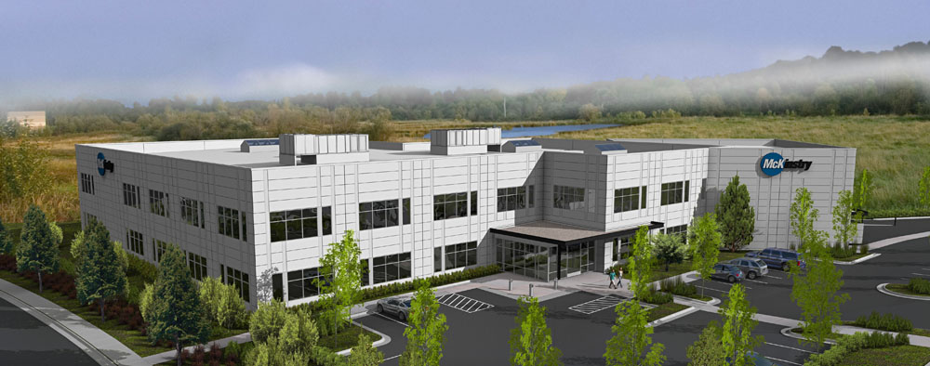
McKinstry Oregon Headquarters
Alex Wyczalkowski December 12, 2008

Prepared for
Dr. Jelena Srebric, Ph.D.
Associate Professor of Architectural Engineering
The Pennsylvania State University

Table of Contents

1 Breadth Proposal 3

1 Breadth Proposal
Lighting
I will first explore a lighting breadth for Senior Thesis. As shown in previous reports, lighting is the largest electrical load in the building. I would like to reduce the lighting load to save energy usage. I will first calculate the total load on a per-luminaire basis. Then I will find new luminaires that can meet the minimum light levels but use less energy. I plan on doing room cavity calculations and using AGI to verify lighting design.
Acoustics
As an possible option, I would like to do an Acoustics breadth to isolate sound from neighboring rooms. Several conference rooms are near other offices. Although large sound isolation may not be needed in this building, I would like to explore what would be necessary to isolate a “confidential” conference room. I will be calculating transmission loss required through the walls and comparing it to NRC ratings of wall constructions.

